Module 1
Introduction to Python IDLE and Python Programs
Lecture 1
The Python IDLE

To write Python programs, we can use the Python IDLE. IDLE stands for Integrated DeveLopment Environment – a set of tools that help programmers develop Python programs.

You can use the IDLE in two modes. The first is the command-line mode - you enter your codes and execute them immediately. The second is the script mode – you type your codes in a text editor, save it as a python file and execute them later.

Writing Your First Program in Command-line Mode

- Open the “Start” menu, and click “All Programs” -> “Python 2.5” -> “IDLE (Python GUI)”.

- What you see is the Python Shell. The symbol >>> is a prompt – it shows that the Python interpreter is ready to execute codes. Type this line of code…
print “I am a Python programmer!”
…and press “Enter”.

- The Python interpreter executes your code and prints…
I am a Python programmer!
…on the next line.

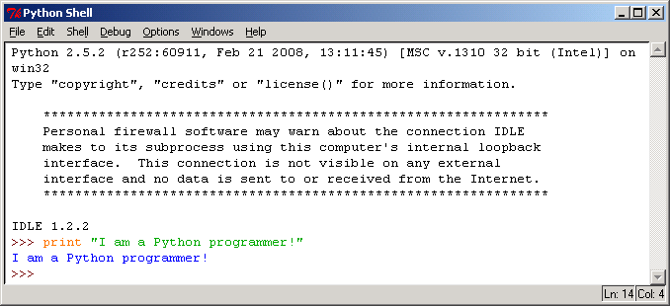

Writing Your First Program in Script Mode

- Still at the Python Shell window, click “File”->”New Window”.

- What you see is the program editor. Type this line of code…
print “I am a Python programmer!”

- Click “File”-> “Save”. Save your file as “python_programmer.py”.
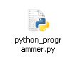

Closing and Opening Your Program

- To close your program, simply close the script window.

- To open it, click “File”->”Open” at the Python Shell window. Browse the file name and double-click the file’s icon.

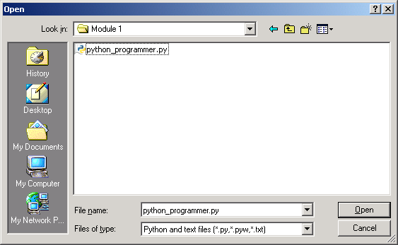

Things to Remember

The line of code…

print “I am a Python programmer!”

…is what is called a statement. A statement is a complete instruction that the Python interpreter can execute. Our statement is made up of a command and an expression. print is a command and commands appear in orange. “I am a Python programmer!” is an expression and expressions appear in green. The result of the Python interpreter executing your program, or output, appears in blue.

Errors – Makes a Programmer’s Life Complete

There are three types of program errors – syntax errors, runtime errors, and semantic errors.

Syntax errors are errors in the structure of your statements. It could be misspelling a command name or mixing up the order of tokens in a statement.

Runtime errors are something unusual that happens when your program is executing and causes the execution to stop. Usually, it’s due to an unexpected event.

Semantic errors occur when your program doesn’t work as you intend it to. Syntax-wise, your program is OK.

If you have a syntax error in your code, you will get an error message when you try to run it. Error messages appear in red in the Python Shell. In script mode, you will get an error message if you try to run a program that has a syntax error in it.

Look at your code again and correct the error. A tip – you can tell that something is incorrectly typed when it appears in black when it should actually be orange or green.

Lab Exercise 1
The Python IDLE

Name:
ID:

There are at least two kinds of syntax errors that can occur when you write the code…

print “I am a Python programmer!”

Give an example of each kind of syntax error. Provide codes to demonstrate your answers.

Example 1
Code:
Explanation:

Example 2
Code:
Explanation:

4 marks
Lecture 2
Printing Text

One of the simplest programs that you can write in Python is a line of code that prints characters. So, let’s begin.

Printing a Line of Text

Syntax | print expression
Example | print “I am a Python programmer!”  print ‘I am a Python programmer!’

The text that you want to print must be enclosed in the same kind of quotes. The quotes act as string delimiters.

Wrong | print “I am a Python programmer!’  print ‘I’m a Python programmer!’

Printing Quotation Marks and Backslashes

Once you’ve used a particular kind of quote as your string delimiters, you must take a special action before you can include it as part of your string correctly. That is, you must precede the quotation mark with a backslash.

Example | print ‘I\’m a Python programmer!’  print “I said, \“I’m a Python programmer!\””

The backslash is used to form escape sequences. When the Python interpreter sees a backslash, it will expect to print something special.

So, you may not print a backslash by providing a single backslash in your string. You need to precede it with another backslash just like you do with quotation marks.

Example | print “This is how you print a \\”

Some other useful escape sequences are shown in the following table.

Escape Sequence | Description
\a | Bell.  Sounds the system bell.
\b | Backspace.  Moves the cursor back one space.
\n | Line feed.  Moves the cursor to the beginning of the next line.
\r | Carriage return.  Moves the cursor to the beginning of the current line.
\t | Horizontal tab.  Moves the cursor forward by three spaces.

Printing Formatted Text

Sometimes, you might want to print some text that you have artistically designed, for example, a heading or a table. Printing them out can get quite tedious using the method you’ve learned so far. Lucky you, there’s a shortcut – using triple-quoted strings. As before, you may use either double quotes or single quotes.

Example | print \  “””  . .  `.___.’  .’ `.  : :\tTaurus – The Bull  : :\tApril 21 – May 21  `.___.’  “””

In the example above, the backslash after the print statement is a line-continuation character. It allows you to break up long codes.

Lab Exercise 2
Printing Text

Name:
ID:

- Write a single print statement that outputs two English sentences on separate lines.

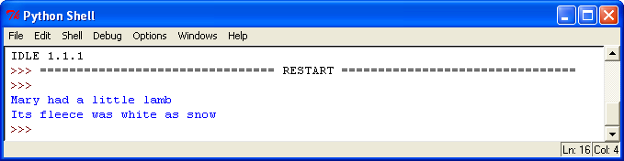

Code:

- Write two different print statements that produce the same output shown below.

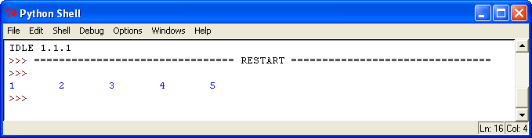

Code:
Code:

3 marks

Lecture 3
Variables

When you tell another person your name, that person remembers it in his memory. If you want your computer program to remember your name, then you must use a variable. A variable is just the name of a memory space which may or may not hold a value.

Creating Variables

Syntax | variable_name = value
Example | my_name = “Junainah”  my_age = 24

In Python, you must initialize a variable to hold some value in order to create it. If you want to create a variable which has no value, then you use the keyword None to signify the absence of a value.

Example | my_own_yacht = None
Wrong | my_own_yacht

Using Variables

To get the value of a variable, just use its name.

Example | print my_name, “ is “, my_age, “years old.”

Naming Variables

Variable names can be made up of the characters A-Z, a-z, 0-9 and _. Remember, a variable name may not begin with a number.

When naming a variable, try to adopt the following guidelines:

- Give short descriptive names, for example, first_name and last_name instead of name1 and name2. A good variable name gives you an idea of the value that it holds.
- When you have more than one word in a variable name, separate each word with an underscore or capitalize the first letter of the each word except for the first word.
- Be consistent with the naming style of your choice. Don’t mix up first_name with lastName.
- Don’t give very long names.
- Don’t use any of the 28 Python keywords as a variable name. They are provided in the list below.

Python Keywords
and | continue | else | for | import | not | raise
assert | def | except | from | in | or | return
break | del | exec | global | is | pass | try
class | elif | finally | if | lambda | print | while

Value Types

A variable’s value can be of any type. Two simple types that you have seen so far are strings and numbers.

A string is a sequence of characters enclosed in double-quotes or single quotes. Whichever kind of quotes you use, make sure that they match and come in pairs.

A number may be an integer or a float. An integer is a whole number while a float is a number with a decimal point.

You can identify the type of value that a variable holds by using the type() function.

Syntax | type(expression)
Examples | print “my_name is of type “, type(my_name)  print “24 is of type “, type(my_age)

Lab Exercise 3
Variables

Name:
ID:

- Give 3 examples of invalid variable names.

a.

b.

c.

- Give 3 examples of valid but bad variable names.

a.

b.

c.

- Give 3 examples of valid and good variable names.

a.

b.

c.

9 marks

Lecture 4
Getting User Input

In the previous module, we learned that a program can use variables to remember values. assigned values to variables using the assignment operator, =.

However, variables become more useful when you use it to hold values entered by a user while your program is running. To get input from the user, we use the functions raw_input() and input().

Getting String Input

The function raw_input() gets a string input from the user. It accepts a string argument within the parentheses which is called a prompt. The prompt should describe the information that the function expects to get from the user. The function returns a string value which is whatever that the user entered into the program.

Syntax | raw_input(string expression)
Example | your_name = raw_input(“What’s your name? ”)  raw_input(“Press the Enter key to escape”)

Getting Numerical Input

The function input() works similarly to raw_input() except that it gets a numerical input from the user. Users may enter integer values or floating-point values.

Syntax | input(string expression)
Example | your_age = input(“What’s your age? ”)

Lab Exercise 4
Getting User Input

Name:
ID:

- Write a program that gets the user’s name and prints a greeting that includes the user’s name. Save it as “greetings.py”.

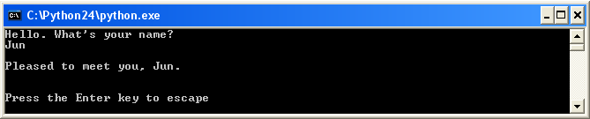

2 marks

- Write a program that gets a numerical input from the user and prints the value type of that input. Save it as “number_type.py”.

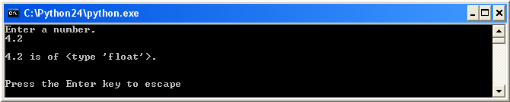

2 marks

Lecture 5
Arithmetic Operations

As we already know by now, there are two types of numbers – integers and floats. The next thing to learn is performing arithmetical operations.

Arithmetical Operations

Syntax | operand operator operand
Examples | my_age_in_2006 = 24 + 1  print “In 2007,I’ll be”, my_age_in_2006 + 1, “\b.”

You can perform an operation on constant values or on variables or both. The following are the arithmetical operators in Python.

Operation | Operator | Explanation
Addition | + | 5 + 2 = 7
Subtraction | - | 5 - 2 = 3
Multiplication | * | 5 * 2 = 10
Division | / | 5 / 2 = 2
Modulus | % | 5 % 2 = 1
Exponentiation | ** | 5 ** 2 = 25

Operator Precedence

When you have more than one operator in an arithmetical expression, some operator will be dealt with before the rest. The order of precedence is shown below.

Precedence | Operator
Evaluate first  .  .  .  .  Evaluated last | Parentheses ()
Evaluate first  .  .  .  .  Evaluated last | Exponentiation **
Evaluate first  .  .  .  .  Evaluated last | Multiplication * and  Division /
Evaluate first  .  .  .  .  Evaluated last | Addition + and  Subtraction -

+ and * Operators and Strings

When used on strings, the + operator is known as the concatenation operator. Concatenation is joining two strings together. Meanwhile, the * operator repeats the same string value by a specified number of times.

Examples | full_name = first_name + “ “ + last_name  print “Sleepy… ” + “z” * 10

Lab Exercise 5
Arithmetic Operations

Name:
ID:

- Write a program that gets two numbers from the user. The program then prints the result of each arithmetical operation on the two numbers. Save the program as “arithmetics.py”.

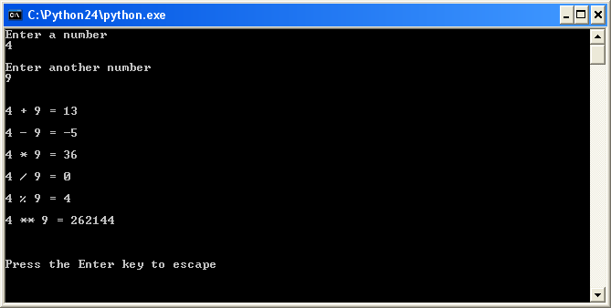

4 marks

- Write a program that calculates the volume and surface area of a sphere. The program must first ask the user to key in a radius value, r, before it performs the calculations. The program should display the result of the calculations. Save the program as “sphere.py”.

Use the following formulae:

Surface area, S = 4πr²

Volume, V = 4/3(πr³)

π = 3.142

6 marks

