Module 3
Repetition Structure

Lecture
Repetition Structure

Besides being able to selectively execute a block of codes, we may also make it execute repeatedly. This is called iteration or repetition. Repetition structure can be written by using either the while statement or the for statement. However, the focus of this module is at the while statement.

As with a conditional statement, an iterative statement also makes use of a Boolean expression as the condition for its execution. As long as the condition is fulfilled, the body of the iterative statement is executed repeatedly.

while Statement

Syntax | while condition:  statement

Optionally, the syntax for the while loop is as shown below with else clause:

Syntax | while condition:  statement  else:  statement

The while statement can be used in just about any situation. Their execution can be controlled in two ways – by using a counter or by using a sentinel value.

Counter-controlled while

A while statement is said to be counter-controlled when we are able to put a number on how many times its body will be executed. In the example below, the body of while executes for ten times.

When we use a counter-controlled while statement, we have to make sure that:

- the counter is initialized to a value that is correct for its intended use.
- there is a statement that alters the counter’s value so that, ultimately, the condition of the while statement is not fulfilled.

Example 1 | counter = 1  while counter <= 10:  print counter, “\t”,  counter = counter + 1

Example 2 | a = 0  while a < 10:  a = a + 1  print a

Output:

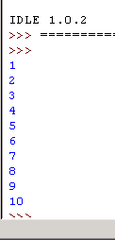

Sentinel-controlled while

A while statement is said to be sentinel-controlled when we cannot say for sure how many times its body will be executed. Instead of using a counter, we would use some input value or a flag value.

In the example below, the input value for variable number is 0. The while body statements:
number = input("Enter a number:")
count = count + 1
sum = sum + number
will be executed repeatedly until user enter 0.

Examples | #keeps asking for numbers until 0 is entered.  #Prints the average value.  count = 0  sum = 0.0  number = 1 #set this to something that will not exit  # the while loop immediatly.  print "Enter 0 to exit the loop"  while number != 0:  number = input("Enter a number:")  count = count + 1  sum = sum + number  count = count - 1 #take off one for the last number  print "The average was:",sum/count

Combination of while and if

The while body statement may contain any program structures: sequential, selection or other repetition structures/statements. Below are 2 examples of program with if statements as part of the while body statements.

Example | a = 0  while a < 10:  a = a + 1  if a > 5:  print a," > ",5  elif a <= 7:  print a," <= ",7  else:  print "Neither test was true"

The output:
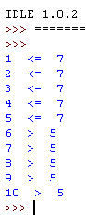

Example 2 | #Plays the guessing game higher or lower  # (originally written by Josh Cogliati, improved by Quique)  number = 78  guess = 0  while guess != number :  guess = input ("Guess a number: ")  if guess > number :  print "Too high"  elif guess < number :  print "Too low"  print "Just right"

The output:

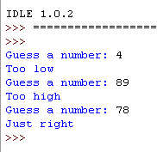

for Statement

When using a for statement, we don’t normally express the condition using comparison operators as how we would with conditionals and the while statement. Instead, we use the in operator. The reason behind this practice is because the for statement is meant to be used to traverse a sequence, for example a string – a sequence of characters. Each character in a string is an element of the sequence. The in operator checks for the occurence of a value in a sequence.

In the example below, the sequence is the string “Junainah”. The elements of the sequence is “J”, “u”, “n”, “a”, “i”, “n”, “a” and “h”. In the first loop, “J” is assigned to the variable letter. The expression “J” in “Junainah” evaluates to True. The loop continues until there are no more letters left.

Syntax | for variable_name in variable_name:  statement
Example | my_name = “Junainah”  for letter in my_name:  print letter

Lab Exercise
Repetition Structure

Name:
ID:

- Write a program that take several numbers and than average the numbers. Users are allowed to choose how many numbers they want to average. Use the following output as a guide for your output layout.

This program will take several numbers than average them
How many numbers would you like to average : 2
Number 1 : 3
Number 2 : 5
The average is : 4.0

This program will take several numbers than average them
How many numbers would you like to average : 1
Number 1 : 10
The average is : 10.0

- Open the program “dice_game.py” that you wrote in Lab Exercise 5. Modify the codes such that the program allows the player to make three throws by using a while statement instead of three if…else statements. Save the program as “dice_game2.py”.

For your convenience, here are the program specifications again:
  - The program asks the player for a number.
  - The program waits for the user to press Enter as a signal for a throw.
  - The program displays the result of the throw.
  - If the result of the throw is the same as the number chosen by the player, then the program tells the player that he has won. Otherwise, the program waits for the player to throw again.
  - If the player fails to throw the number after three chances, then the program tells the player that he has lost.

- Write a program that prompts the user for a string. The program then counts the occurrence of a letter specified by the user. Lastly, the program displays the number of times that the letter occurs in the string. Save the program as “letter_counter.py”.

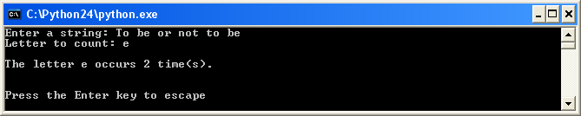

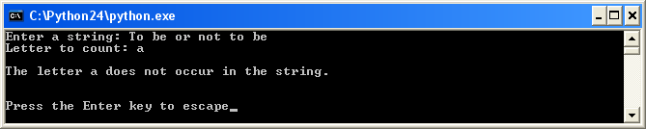

- As input for program receipt, a cashier enters in the data for each of the customer’s purchases. Each data group consists of an item name, the price of the item, and the quantity of that item being purchased. The data sentinel xyz is used instead of an item name. Here is the screen display for a typical run that would also produce a sales receipt.

Sample output:
Enter item name or xyz to stop pencil
Enter price per item 2.5
Enter the quantity 3
The price is RM 7.50
Enter item name or xyz to stop scissors
Enter price per item 3
Enter the quantity 2
The price is RM 6.0
Enter item name or xyz to stop xyz

- Ulam’s Conjecture – The following conjecture is know as Ulam’s conjecture after the mathematician S.Ulam :
- Start with any positive integer
- If it is even, divide it by 2
- If it is odd, multiply it by 3 and add 1
- Obtain successive integers by repeating the process as long as the current integer is not 1
- Eventually, you will obtain the number 1 regardless of the starting integer.
- For example, when 26 is the starting integer, the sequence will be

26 13 40 20 10 5 16 8 4 2 1

- An applicant for a secretarial job will be given a maximum of five typing tests. The applicant will be hired as soon as he or she scores over 50 words per minute on two tests. Write a program that allows a supervisor to enter each typing test score on completion of each test. The program should print Hire as soon as the applicant qualifies without asking for further tests. If after five test scores have been entered the typist still hasn’t qualified, the program should print reject.
Sample output 2:

Enter score 31
Enter score 45
Enter score 53
Enter score 22
Enter score 12
Reject

Sample output 1:

Enter score 50
Enter score 45
Enter score 55
Hire

