Module 5
Functions – Predefined and User-Defined
Lecture 1
PREDEFINED FUNCTIONS

We have been acquainted with a few functions, namely, type(), raw_input(), and input(). They are a just a small sample of Python’s several built-in functions. Some functions are collectively grouped in modules. The reason why they are grouped together is because they perform tasks that are related.

A function is a piece of code that does something specific. You call it in your codes by its name. Depending on the function, it might take an argument and return a return value.

Converting Type

Below are the functions that perform type conversions.

Function Name | Argument(s) | Return Value
int() | Value of any type. | Argument in integer type, if possible.
float() | Value of any type. | Argument in float type, if possible.
str() | Value of any type. | Argument in string type.

Examples | an_integer = int(raw_input(“Enter an integer: \n”))  a_string = “12”  another_string = “34”  print a_String + another_string  print int(a_string) + int(another_string)

Generating Random Numbers

To generate random number, we need to import the random module. The function that gives you the random number is randrange(). Unlike the previous functions we’ve seen, we need to call the function using the dot notation. The function accepts a positive integer argument.

Syntax | random.randrange(positive_integer_value)

Example | import random  random_number = random.randrange(6)

The randrange() function returns a positive integer value from 0 to some number. The argument that it takes specifies the number of integers starting from 0 onwards that would be returned. In the example above, the range is 0, 1, 2, 3, 4, and 5 – six numbers altogether. You may also take this to mean that randrange() returns a value from 0 to the number one less of the argument.

Lab Exercise 1
Predefined functions

Name:
ID:

Open the program “sphere.py” that you wrote in Lab Exercise 5 of Module 1. Modify the codes such that instead of getting the radius value from the user, the program generates a random value as the radius. For convenience, the radius value should be between 1 and 10. Save the program as “random_sphere.py”

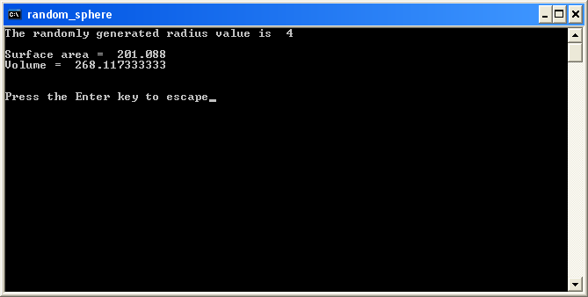

2 marks

Lecture 2

USER-DEFINED Functions

Now that you know what functions are and how to use them, you are ready to create your own functions. You might wonder why you would want to do that. One reason is that functions enable you to break up a complicated program into manageable chunks. Another reason is that when you’ve defined a block of codes as a function, you may use it again and again by just calling your function – saving you many lines of codes.

Creating Your Own Functions

When we create a function, we give it a name and write statements that give our function something to do. We define it with the def keyword.

Syntax | def function_name():  statement
Example | def greet():  print “Hello, you!”

In the example, the function is greet()and all it does is print the string “Hello, you!”. Take note that a function name must always be followed with a pair of parentheses. Plus, a function name may not be a Python keyword.

As demonstrated, functions could be as simple as you wish it to be. Functions do not have to be complicated. In fact, it’s a good idea to keep them simple, short and sweet.

Ideally, a function should only do one specific thing. You’ll know when your function is trying to do too much when you cannot give it a name that describes exactly and completely what it does.

Once defined, we only need to call our function in order to get it to perform its job.

Example | 1. def greet():  print “Hello, you!”  greet()  Output :  Hello, you  2. def hello():  print "Hello"  def welcome():  print "Welcome!"  print "How are you?"  hello()  welcome()  hello()  Output:  Hello  Welcome!  How are you?  Hello

Always remember that a function’s definition has to be executed before you may call it. In other words, put the definition before the call in your program’s codes.

Creating Functions that Take Arguments

A function might need to take an argument in order for it to do its job. You pass the argument to the function in the function call. The argument is then assigned to a parameter – which is just another variable. In the function definition, you just need to include a parameter in the parentheses and use the parameter anywhere in the function’s statements.

Syntax | def function_name(parameter_name):  statement
Example | def greet(user_name):  print “Hello,“ ,user_name, “!”

To see the function in action, simply call it and pass it an argument.

Example | 1. def greet(user_name):  print “Hello,“, user_name, “!”  user_name = raw_input(“What’s your name? “)  greet(user_name)  Output:  What's your name? ana  Hello, ana !  2. def hello():  print "Hello"  def calculate_age(year):  age = 2006 - year;  print "Your age is ", age  hello()  year = input ("Please input your born year: ")  calculate_age(year)  Output:  Hello  Please input your born year: 2000  Your age is 6

Take note that a function’s parameters are local to the function – those parameters do not exist outside of the function. Same goes for any other variables which are created in that function.

Creating Functions that Return a Value

Most of the built-in functions that you’ve used return a value. For example, raw_input() returns a string value that you can assign to a variable. You can make your own functions return a value by using a return statement.

Syntax | def function_name(parameter_name):  statement  return value
Example | 1. def return_number():  return 10  print "This is only example "  a= return_number()  print a  Output:  This is only example  10  2. def return_number():  return 10  #print return value inside 'print' statement  print "The number is :", return_number()  Output:  The number is : 10  3. def odd_or_even(x):  if x % 2 == 0:  return "even"  else:  return "odd"  a_number = input("Enter an integer: ")  print a_number, "is", odd_or_even(a_number)  Output:  Enter an integer: 20  20 is even

To see the function in action, simply call the function and use the return value appropriately.

Example | a_number = input(“Enter an integer: “)  print a_number, “is“, odd_or_even(a_number)

The return statement causes the termination of the function it is in and the return of control to the calling function. However, it can be written with or without a return value.

Example | def odd_or_even(x):  if type(x) != type(1):  print “Integers only, please!”  return  if x % 2 == 0:  return “even”  else:  return “odd”  a_number = input("Enter an integer: ")  if odd_or_even(a_number):  print a_number, "is", odd_or_even(a_number)

Creating Recursive Functions

A plain of function becomes a recursive function when there is a statement in its body that calls itself. A recursive function only knows one thing -the solution to the simplest problem or base case. If the problem is complicated, then it calls and passes itself a less complicated problem. It will keep calling itself until the problem becomes the base case.

In the example below (for factorial), the base case is n == 0. When n is any integer other than zero, the function modifies the original problem to make it simpler but still bears some resemblance to the original problem.

Example | def factorial(n):  if n == 0:  return 1  else:  return n * factorial(n – 1)  a_number = input("Enter an integer: ")  print a_number, “! =", factorial(a_number)  Output:  Enter an integer: 4  4 ! = 24  2. def fibonacci(n):  if n == 0 or n == 1:  return n  else:  return fibonacci (n -1) + fibonacci (n-2)  a_number = input("Enter an integer: ")  print "Fibonacci ", a_number, " =", fibonacci(a_number)  Output:  Enter an integer: 3  Fibonacci 3 = 2

The diagram to show how to get fibonacci (3)

fibonacci(3)

return fibonacci (2) + fibonacci (1)

return 1

return fibonacci (1) + fibonacci (0)

return 1 return 0

The answer = (return 1 + return 0) + return 1
= 1 + 0 + 1
= 2

Lab Exercise
Functions

Name:
ID:

- What is the output for the following program?

def star():
print "*****"

def lines():
for x in range(1,5):
print ("-----")

def symbol():
print ("$$$$$")

star()
symbol()
star()
lines()
star()

- Define a function called hypotenuse that calculates the length of a right triangle when the other two sides are given. The function should take two arguments for the two side and return the hypotenuse

- Write a function that returns the smallest of three floating point numbers.

- Write a recursive function that produces the same output as the codes below. Your function should count from n to 1.

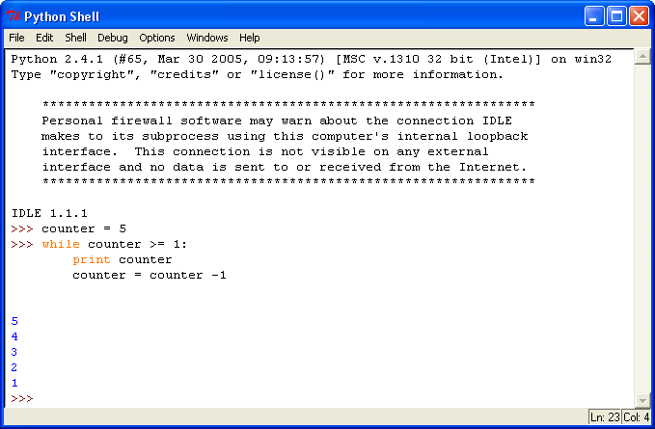

5. Modify the recursive function so that it counts from 1 to n.

