Module 4
Lists

Lecture
Lists

A list is a sequence of elements that can be of any type. It can contain a string, a number, or even another list. It doesn’t hurt to have all of a list’s elements to be of the same type either. You may think of a list as a variable that stores a set of values. As an example, you may create a list that contains a name, an age, a birthday, and an address.

Creating a List

Syntax | list_name = [list_element_1, list_element_n]
Example | groceries = [“bread”,“milk”,“apples”,“cake”]

In the example above, groceries is the name of the list. It has four string elements in it – ”bread”, ”milk”, ”apples”, and “cake”, which are enclosed in square brackets and separated by commas. You may include more elements than that or none at all.

Getting the Length of a List

To get the length of a list, we use the len() function.

Syntax | len(list_name)
Example | groceries = [“bread”,“milk”,“apples”,“cake”]  print “There are”, len(groceries), \  “elements in the list”

Take note of the backslash after len(groceries), . It is a line continuation character and allows you to split a statement.

Traversing a List

To traverse a list, we use the in operator.

Example | groceries = [“bread”,“milk”,“apples”,“cake”]  for item in groceries:  print item

Accessing an Element in a List

To access an element in a list, we specify its index number.

Example | groceries = [“bread”,“milk”,“apples”,“cake”]  print groceries[0]  print groceries[1]  print groceries[2]  print groceries[3]

The first element is indexed as 0 while the last element is indexed as one less of the length of the list. The index must be enclosed in square brackets.

Accessing a Slice of a List

A slice is a “sub-list” or a portion of a list. To slice a list, we specify its two end points in square brackets separated by a colon.

Example | groceries = [“bread”,“milk”,“apples”,“cake”]  print groceries[1:3]

In the example above, the slice is a list of two elements – [“milk”, “apples”]. The slice begins at groceries[1] and ends before groceries[3].

Concatenating Lists

To concatenate lists, we use the + operator.

Example | groceries = [“bread”,“milk”,“apples”,“cake”]  toiletries = [“shampoo”,“toothpaste”]  shopping_list = groceries + toiletries  shopping_list = shopping_list + [“newspaper”]  print shopping_list

However, you may only concatenate a list to another list. You may not concatenate a string, for example, to a list.

Wrong | shopping_list = shopping_list + “newspaper”

Replacing an Element for Another

To replace an element for another element, we assign the new element to the index.

Example | toiletries = [“shampoo”,“toothpaste”]  toiletries[0] = “soap”  print toiletries

However, you may not do the same to add a new element to the list. The index must already exist before you can access it.

Wrong | toiletries = [“shampoo”,“toothpaste”]  toiletries[2] = “soap”

Replacing a Slice for Another

To replace a slice for another slice, we assign the new slice to the end points.

Example | groceries = [“bread”,“milk”,“apples”,“cake”]  groceries[1:3] = [“oranges”]  print groceries

Take note that you can replace a slice with another that is not of the same length. However, you must ensure that you replace the old slice with another list. Replacing it with a single value ends up “strange”.

Wrong | groceries = [“bread”,“milk”,“apples”,“cake”]  groceries[1:3] = “oranges”  print groceries

Deleting an Element or a Slice

To delete an element or a slice, we use the del command.

Example | groceries = [“bread”,“milk”,“apples”,“cake”]  del groceries[0]  print groceries  del groceries[1:3]  print groceries

The append() Method

To append means to add to the end of something. It’s similar to concatenation but concatenation only allows you to put two lists together. The append() function allows you to put a single value to a list.

Example | groceries = [“bread”,“milk”,“apples”,“cake”]  groceries.append(“newspaper”)  print groceries

The remove() Method

The remove() method allows you to delete an element without using its index. The method simply looks for an element with the value that you specify and removes it. However, it only removes the first occurrence of that value. If there are two elements with the same value, then only the first one will be removed.

Example | groceries = [“bread”,“milk”,“apples”,“cake”]  if “apples” in groceries:  groceries.remove(“appples”)  print groceries

Take note that you may only remove a value that already exists in the list. If you try to remove a value that is not in the list, then you will get an error.

The sort() Method

The sort() method allows you to sort a list in ascending order.

Example | groceries = [“bread”,“milk”,“apples”,“cake”]  groceries.sort()  print groceries

The reverse() Method

The reverse() method reverses a list.

Example | groceries = [“bread”,“milk”,“apples”,“cake”]  groceries.reverse()  print groceries

You can use this method to sort a list in descending order.

Example | groceries = [“bread”,“milk”,“apples”,“cake”]  groceries.sort()  groceries.reverse()  print groceries

Lab Exercise
Lists

Name:
ID:

Write a program that allows a user to create a list. Save it as “list_manipulator.py” .

The specifications of the program are as follows:
- The program asks the user for the length of the list
- Next, the program asks the user to key in the elements one by one
- After all the elements are listed, the program displays the list
- Next, the program displays a menu of four choices
  - Append – The user keys in a value to be appended to the list
  - Remove – The user keys in a value to be removed from the list
  - Print – The list is printed
  - Exit – The program ends
- After append and remove, the program displays the resulting list and the menu again

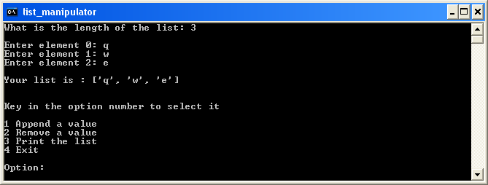
Figure 1 The Beginning of the Program

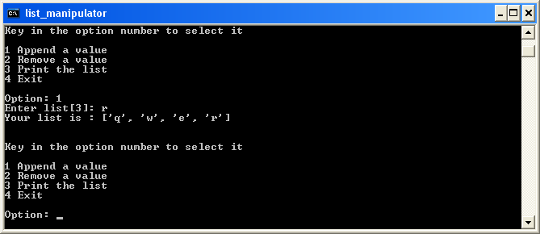
Figure 2 Appending a New Element

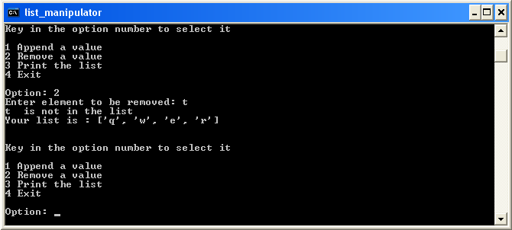
Figure 3 Removing a Non-Existing Value

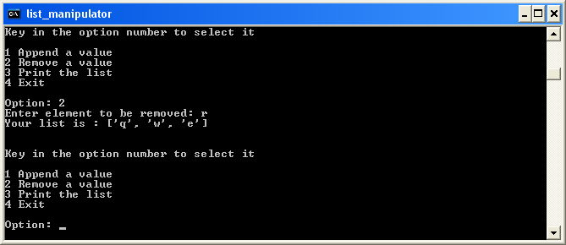
Figure 4 Removing an Existing Value

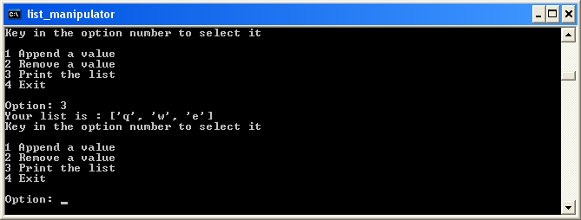
Figure 5 Printing the List

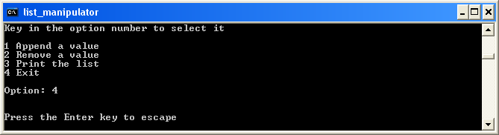
Figure 6 Exiting from the Program

